### 

### What is the difference between T-568A and T-568B?

Congratulations! You just finished crimping your RJ45. Now, you may wonder about the color coding. The T-568A and T-568B are having different color coding. What is the purpose? Let me put it this way, T-568A + T-568A = Straight-through and T-568B + T-568B = Straight-through but **T-568A + T-568B = Crossover**. Take a look at the images below.

**What devices that straight-through and crossover connect?**

Straight-through is normally used for connecting different network devices such as:

* Router to hub and vice-versa
* Hub to computer
* Computer to switch

 On the other hand Crossover cable is used to connect similar devices, the likes of:

* Router to router
* Hub to hub
* Switch to switch
* Computer to Computer
* Router to computer (Router to computer uses crossover cable because they both have an IP address. The only exception as far as I know)

  Done…I believe that you are now equipped with knowledge about crimping your own network cable.

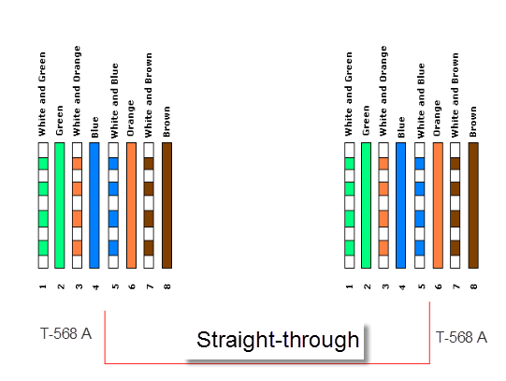

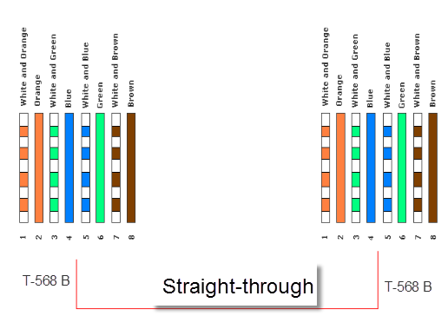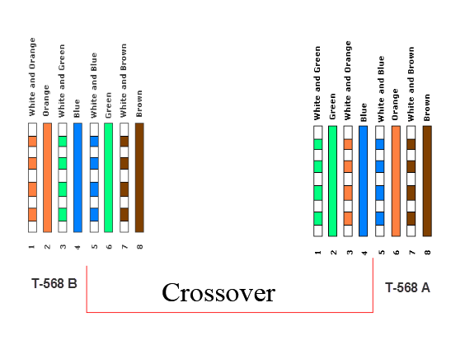

# RJ45 Pinout

A RJ45 connector is a modular 8 position, 8 pin connector used for terminating Cat5e or Cat6 twisted pair cable. A pinout is a specific arrangement of wires that dictate how the connector is terminated. There are multiple pinouts for RJ45 connectors including straight through (T568A or T568B), crossover, rolled, T1, and loopback. Straight through is the most common type of cable and is used for connecting your computer to your network. The other pinouts are for specialty cables that are used for unique network applications.

**Straight-Through Pinout**  
Within the family of straight-through color codes, there are two standards recognized by ANSI, TIA and EIA. The first is the T568A wiring standard and the second is T568B. T568B has surpassed 568A and is seen as the default wiring scheme for twisted pair structured cabling. If you are unsure of which to use, choose 568B.

**T-568A RJ45 Pinout**  
[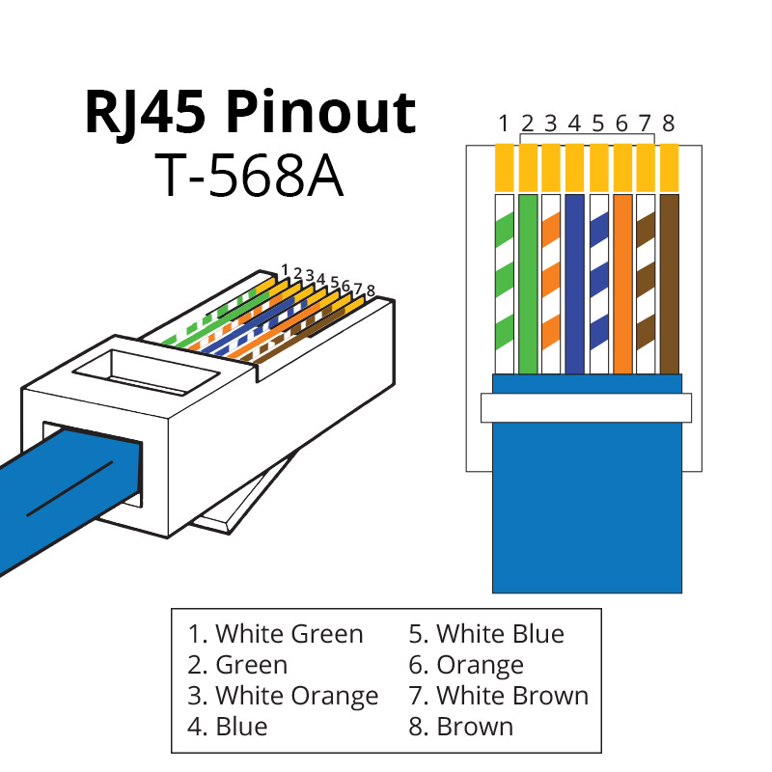](http://blog.showmecables.com/wp-content/uploads/2015/03/RJ45-Pinout-T568A.jpg)

**T-568B RJ45 Pinout**  
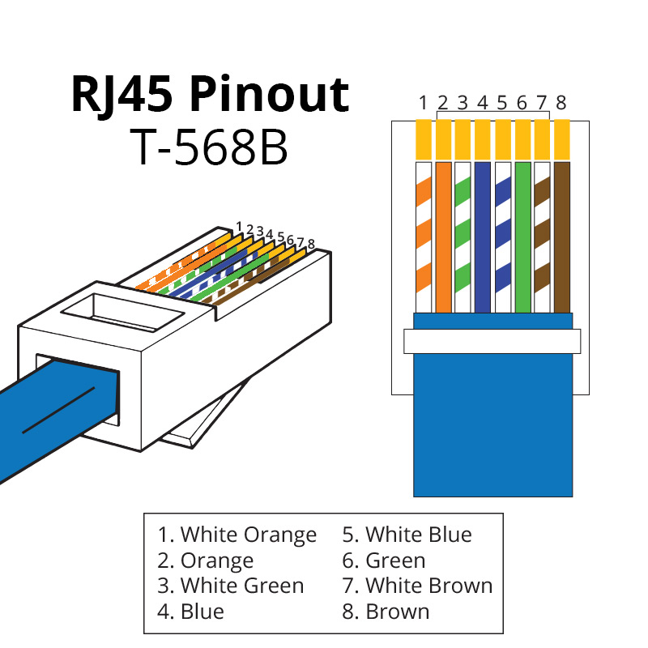

**Cross Over Pinout**  
A crossover cable utilizes two different RJ45 pinouts for the two ends of the cable. If you need to connect 568A equipment to 568B you can use a crossover cable.

[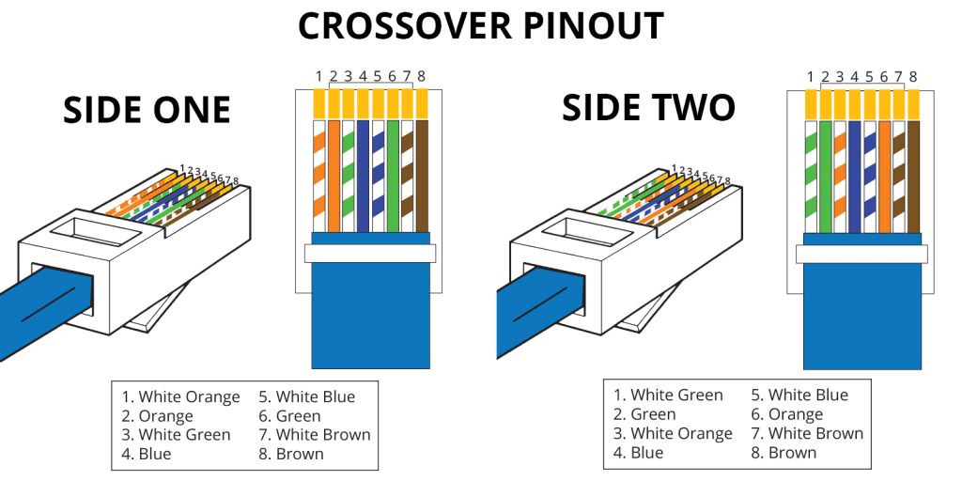](http://blog.showmecables.com/wp-content/uploads/2015/03/Crossover-Pinout.png)

# Ethernet Cables - RJ45/Colors & Crossover

|  |
| --- |
| http://www.bb-elec.com/Images/EthernetRJ45A-%281%29.aspx   http://www.bb-elec.com/Images/EthernetRJ45B.aspx  This diagram shows how Ethernet cable color coding works. Alter cables at your own risk.   Ethernet cable color-coding exists as part of the industry standard - T568A/T458B. Standards exist so technicians can know how the cable should work and can reliably alter the cable when necessary. |